About Eniac:

We are in the summer of 2018. Eniac is an online marketplace specializing in Apple-compatible accessories. It was founded ten years ago in Spain and has since grown and expanded to other neighboring countries.

In addition to offering a wide catalog of products at competitive prices, Eniac provides friendly and professional tech support and consultation to its customers. The warmhearted spirit that thrives with direct contact with the customers is at the core of the company.

Here are some numbers that will help you understand Eniac’s scope (data from April 2017 to March 2018):

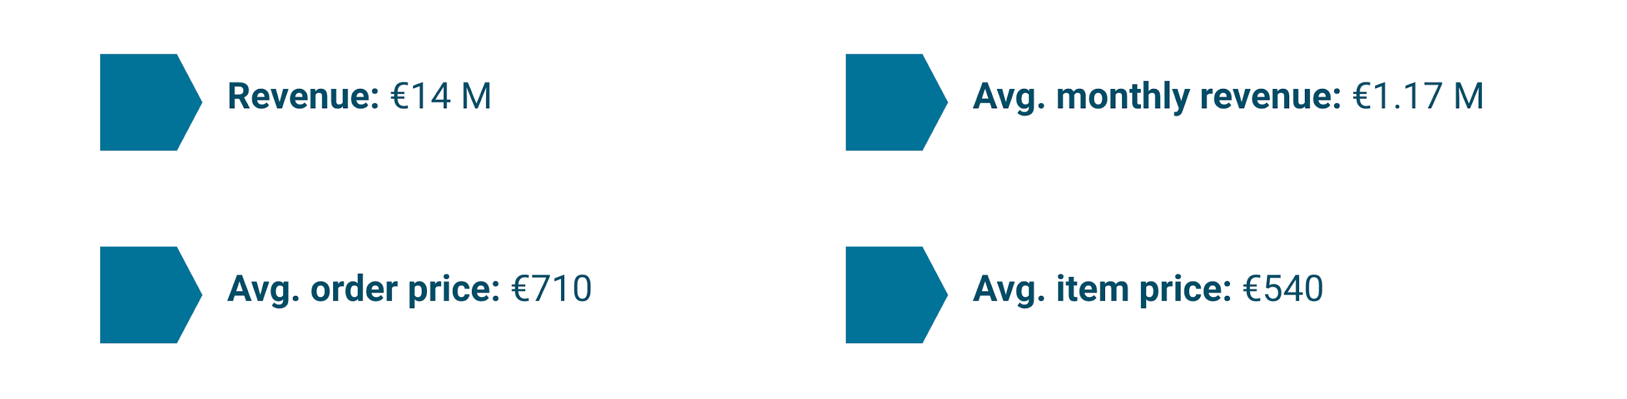

The company has high hopes put into the possibilities that come with Data Analysis, and they are especially hopeful that your work can finally settle an ongoing debate: whether or not it’s beneficial to discount products.

* The Marketing Team Lead is convinced that offering discounts is beneficial in the long run. She believes discounts improve customer acquisition, satisfaction and retention, and allow the company to grow.
* The main investors in the Board are worried about offering aggressive discounts. They have pointed out how the company’s recent quarterly results showed an increase in orders placed, but a decrease in the total revenue. They prefer that the company positions itself in the quality segment, rather than competing to offer the lowest prices in the market.

Your analytical and business skills are needed to provide clarity in the following aspects:

* How should products be classified into different categories to simplify reports and analysis?
* What is the distribution of product prices across different categories?
* How many products are being discounted?
* How big are the offered discounts as a percentage of the product prices?
* How do seasonality and special dates (Christmas, Black Friday) affect sales?
* How could data collection be improved?